Executive Summary (*3) (10 marks)
Oatmeal are basically foods that are taken as breakfast since they are light foods. Also, Oatmeal's are healthy foods that impact our health positively. For instance, Oatmeal's are highly nutritious; also, whole Oatmeal is rich in Antioxidants, oatmeal contains a strong soluble fiber known as the Beta-Glucan, and finally, Oatmeal improve the health of the body by maintaining the required level of blood sugar.

• Introduction/description of Process (*4) (5 marks)
Introduction.
Oatmeal falls under the category of healthy meals that may contribute to reducing obesity among individuals. Most of the oatmeal are taken during breakfast since they are light foods. In addition to Oatmeal, it's a very healthy meal that gets one's motor functioning throughout the day if undertaken by an individual as well as it can be a very delicious meal if made well (Mackie et al., 2017). Oatmeal is highly associated with significant benefits. Such benefits of consuming or taking Oatmeal as a breakfast include- oatmeal are highly nutritious; also whole Oatmeal is rich in Antioxidants, oatmeal contains a strong soluble fiber known as the Beta-Glucan, Oatmeal improve the health of the body by maintaining the required level of blood sugar, and finally Oatmeal aids people who have issues associated with obesity lose their weight. Consumption of Oatmeal aids in reducing the risks of heart diseases that have become more prone to peoples.
In order to develop a basic recipe for cooking Oatmeal, one has to be fully equipped with various tools that will enable one to progress smoothly without difficulties. Therefore, all the requirements one needs in order to come up with his or her own Oatmeal, especially at the homestead, include the Oatmeal itself, the salt and sugar in case one wants to make the Oatmeal sweet, and finally bags that sealable for storing the Oatmeal (Wack, 2018). The main purpose served by salt is to enhance flavor among foods. Thus the use of salt in the cooking or preparation of Oatmeal tends to bring out the inherent but subtle sweetness and nuttiness of the oat. In the Oatmeal preparation, it is always advisable to only add low-calorie sweeteners or a small amount of sugar, considering that the use of more-calorie sweeteners such as honey significantly contributes to raising the blood glucose level within one's body.
The process of preparing the Oatmeal is easy. Such a procedure of preparing Oatmeal commences by adding some amount of Oats to the sealable bag, preferably a quarter of a cup. The next step is taking some salt, preferably one teaspoon, and putting it in a separate bag with the Oats (Lee et al., 2018). The other step entails pre-adding a small quantity of sugar, preferably of about half a teaspoon, to enhance the Oatmeal's sweetness. Adding sugar depends on the individual preparing the Oatmeal since one can choose to add some amount of sugar or none. After preparing the Oatmeal, one can either flavor it or not.
• Analysis Tools (15 marks)
o Flow diagram
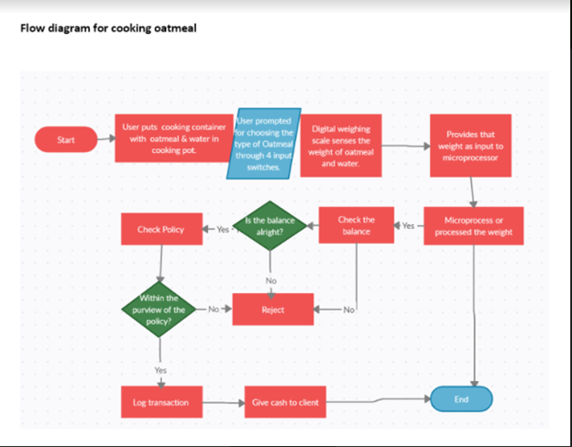
o Operations Process Chart
o Process Flow Chart
o Left Hand/ Right Hand


• Possible Improvements with Proposed Process (10 marks)

• Comments and Conclusion (10 marks)

